VI_12: X-ray diffraction:
For diffraction pattern to be observed, the wavelength of the radiation should be of the same order of the diffraction element. The wavelength of the X-rays is comparable to the interatomic distances in crystals.
X-ray diffraction is a phenomenon in which the atoms of a crystal, by virtue of their uniform spacing, cause an interference pattern of the waves present in an incident beam of rays. The atomic planes of the crystal action the X-rays in exactly the same manner as does a uniformly ruled grating on a beam of light.

Bragg’s equation:

Bragg’s equation is a relation between the spacing of the atomic planes in crystal and the angles of incidence at which these planes produce the most intense reflection of electromagnetic radiations, such as X-rays and gamma rays and particle waves, such as those associated with electrons and neutrons.
Let a crystal be made up of equidistant parallel planes of atoms with interplaner distance ‘d’. A monochromatic ray of X-rays PA of wavelength λ is incident at an angle θ with the atomic planes. AQ is the corresponding reflected beam. PB is an another incident beam with the same angle θ and BS its reflected ray.

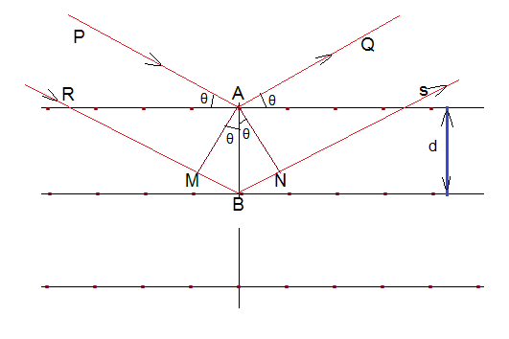
AM and AN are perpendiculars on RB and BS. The path difference between the two reflected beams AQ and BS is ∂ = MB + BN.

In ∆MAB, Sin θ= $\frac{MB}{AB}$ = $\frac{MB}{d}$ , or, MB = d sin θ, (d is the interplaner separation).
From the ∆BAN,
sin θ = $\frac{BN}{AB}$ = $\frac{BN}{d}$ , or, BN = d sin θ
So, path difference = MB + BN = 2d sin θ … … … … … … (1)

For maximum intensity of reflected wave trains, they must be in phase (to produce constructive interference). Thus, if the two consecutive planes scatter X-rays in the same phase, then the path difference must be integral multiple of λ,
i.e., ∂ = n λ … … … … … .. (2)
where n = 0, 1, 2, … is the order of reflection.
From equations (1) and (2)
n λ = 2d sin θ … … … … … … (3)
This is known as Bragg’s law. Thus, Bragg’s law is defined as the X-rays reflected from different parallel planes of a crystal interfere constructively when the path difference is integral multiple of the wavelength of X-rays.
The Bragg’s law is useful for measuring wavelengths and for determining the lattice spacing of crystals. To measure a particular wavelength, the radiation beam and the detector are both set at some arbitrary angle θ. The angle is then modified until a strong signal is received. The Bragg angle, as it is called, then gives directly the wavelength from the Bragg’s law. This is the principal way to make precise energy measurement of X-rays and low energy gamma rays.

