VI_11: Cesium Chloride (CsCl) structure:
The radius of Cs⁺ is (r_{Cs} )1.69Å and that of Chlorine (r_{Cl}) is 0.181 Å. If the atomic radius of the constituent atoms ranges between 0.732 and 1, the structure will be a BCC. Now, as r_{Cs}/ r_{Cl} = 0.933, so the structure of Cesium chloride will be a body centered cubic cell. Also, as r_{Cl} $>$ r_{Cs}, the corners of the cell will be occupied by Cl atoms and the center will be occupied by the Cs atom.
The corner atoms effectively contribute one atom to the cell since each corner is shared by eight cubes as there are eight corners. Thus, there are effectively two atoms (1/8 x 8 + the atom at the center) in cell.

The lattice points of CsCl consists two interpenetrating simple cubic lattice, one occupied by Cs⁺ ion and the other by Cl⁻ ion. So, the co-ordination number is 8. ……. (See *1).
So, for CsCl, 2( r_{Cs} + r_{Cl} ) = $\sqrt{3}$a. (See *2).
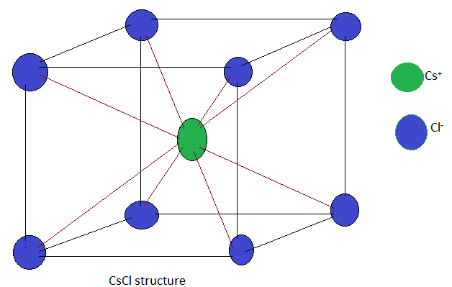

Or, a = $\frac{2}{\sqrt{3}}$ ( r_{Cs} + r_{Cl} )
So, atomic packing fraction (PF) = $\frac{Volume occupied by the atoms}{Total volume of the unit cell}$

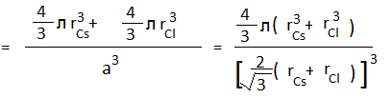

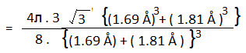

= $\frac{\left(3.14\right). \left(1.732\right). (4.826+5.929 ) }{2 ( 42. 875)}$

= $\frac{58.490}{85.75}$ = 0.682
Or, PF = 68%.
So, void (blank area within the cell ) = 100% - 68% = 32%.

