VI_9: Zinc Blend (ZnS) structure:
The structure of ZnS is identical to diamond structure except that the two interpenetrating sub-lattices are occupied by different elements.
The no of atoms: There are 8 atoms in the eight corners and 6 atoms of the face-centers. So, total no. of sulpher atoms = (1/8 x 8) + (1/2 x 6) = 4, as each eight corner atoms will be shared by eight other cell and each face centered atom will be shared by two cells.
There are 8 tetrahedral voids at each corner of the cubic cell. Zn will exist in alternate void and the no. of Zn atoms=4. As Zn atom will lie on alternate tetrahedral void, there are 4 Zn atoms and hence four out of eight tetrahedral void will remain blank.
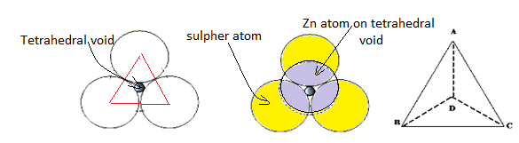
ZnS is an ionic crystal and should be written as Zn²⁺, S²⁻
Atomic radius of Zn²⁺ = 0.74 Å and that of S²⁻ = 1.84 Å.
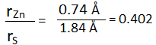
As r_{s} $>$ r_{Zn} , atoms with bigger radius (i.e., Sulpher) will make tetrahedral structure.
Tetrahedral voids are formed on the body diagonal.
Every Zn²⁺ is surrounded by 4 ⁺, S²⁻ ions and every ⁺, S²⁻ ion is surrounded by 4 Zn²⁺ ions. So the co-ordination number of both the ions is 4.
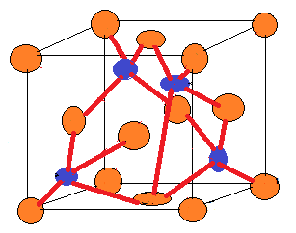
For ZnS,
4( r_{Zn} + r_{S} ) = $\sqrt{3}$ a,

or, a = $\frac{4}{\sqrt{3}}$ (( r_{Zn} + r_{S} ), where r_{Zn} and r_{S} are the radii of Zn²⁺ and S²⁻ respectively. (As there are 4 ions each, we are multiplying by 4).
Total volume of the four Zn²⁺ is {4 x $\frac{4}{3}$ $π$ r_{Zn}³} and that of the four S²⁻ is {4 x $\frac{4}{3}$ $π$ r_{S} ³}.
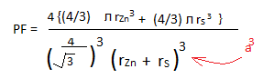

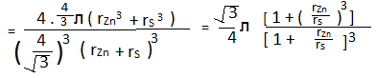
Important compounds having this (ZnS like) structure are semiconductors In, Sn, and GaAs, CuCl, CdS,
AgI, ZnSe, SiC etc.

[The crystalline solids are characterized by their space lattices and close packing of atoms. However, these structures have some gaps in their arrangement we call voids.
A regular tetrahedron is one in which all four faces are equilateral triangles. In geometry, an equilateral triangle is a triangle in which all three sides are equal. The angles between the arms are 60⁰.]

Method of drawing the structure:
