VI_7: Hexagonal Closed Packed (HCP) structure:
The hcp has three layers of atoms. In both the top and bottom layers, there are six atoms that arrange themselves in the shape of a hexagon and a seventh atom that sits on the middle of the hexagon. The middle layer has three atoms nested in the triangular grooves of the top and bottom plane (the three atoms are within the body of the unit cell.
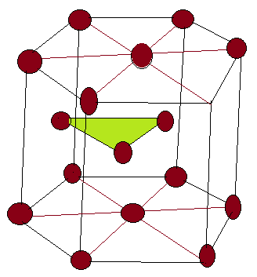
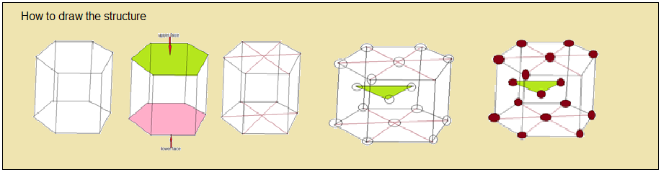
The hcp is very common for elemental metals including Berilium(Be), Cadmium(Cd), Magnesium(Mg), Titanium(Ti), Zinc(Zn), Cobalt(Co), Tellurium(Tl) etc.
Packing fraction: Three atoms within body of the cell have full contribution to the cell. The top layer contains seven atoms, each corner atom is shared by surrounding hexagonal cells. The center atom is shared by two adjacent cells.
Therefore, in a unit cell, the total number of atoms = $3/2$ + $3/2$ + 3 = 6 … …. …*i.

Volume of all atoms per unit cell v = 6 x$\frac{4}{3}$ л r³ = 8 л r³ = 8 л($\frac{a}{2}$)³ = л a³ … … … … … … … … … … (1)
Where 2r = a = nearest neighbor distance.

Volume of the unit cell = V = 3 $\sqrt{3}$ a² c /2 … …. … … … *ii

Where c =height of the cell.

Henece, Packing Fraction = v/V = л a³ / (3 $\sqrt{3}$ a² c /2) =$\frac{2л}{3 \sqrt{3}}$ ( $\frac{a}{c}$)

It can be shown that in a hexagon, $\frac{c}{a}$ = $\sqrt{8/3}$

So, PF for hcp = $\frac{2л}{3 \sqrt{3}}$ $\left(\sqrt{3/8}\right)$ = л / $3 \sqrt{2}$ = 0.74 or 74%.
