VI_M_5. Body Centered Cubic (BCC):
In body centered cubic lattice, there is one additional lattice point situated at the body center besides eight lattice point at the eight corners. So, total number of lattice points per BCC unit cell is:
(1/8 x 8 ) + 1 = 2.
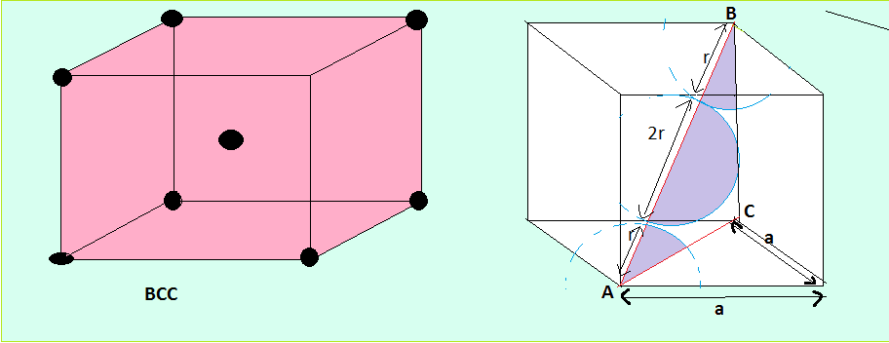

In the BCC unit cell, AC² = a² + a² = 2a² , So, AC = $\sqrt{2}$ a.

AB² = AC² + CB² = ($\sqrt{2}$ a)² + a² = 3a² , so AB = $\sqrt{3}$ a. … …. ………… ……………. (1)

AB = r + 2r + r = 4r,

So, 4r = $\sqrt{3}$ a

Hence, atomic radius of a BCC crystal is r = $\frac{\sqrt{3} a}{4}$ ……… ……. ….. (2)

The nearest neighbor distance d = 2r = $\frac{\sqrt{3} a}{2}$ … … … … …. …. … (3)

In BCC structure, the number of atoms per cell is 2. So, volume of two atoms = 2. $\frac{4}{3}$ л r³

As r = $\frac{\sqrt{3} a}{4}$ , total volume occupied by the two atoms v₁ = 2. $\frac{4}{3}$ л. ($\frac{\sqrt{3} a}{4}$ ) = $\frac{\sqrt{3} }{8}$ л a³ … .. (4)

Volume of the unit cell V = a³

Hence, Packing Fraction = v₁ / V = ( $\frac{\sqrt{3} }{8}$ л a³ ). (1/a³) = $\frac{\sqrt{3} }{8}$ л = 0.68,

Or, in percentage, PF x 100 = 68%
i.e. 68% of the unit cell is occupied by the atoms.
Example: Iron, Sodium, Chromium etc.

