Lattice Constants:
The length a, b, c specifying the size of a unit cell are called lattice constants.
In the special case of cubic crystal structures, all of the constants are equal (i.e. a = b = c ) and we only refer to ‘a’. Similarly, in hexagonal crystal structures, the a and b constants are equal and we only refer to the ‘a’ and ‘c’ constants.
The lattice constant refer to the physical dimension of unit cell in a crystal lattice. The primitive basis vectors a, b, c and interfacial angles α, β, ϒ are called the “lattice parameters” as they determine the form and actual size of the unit cell.
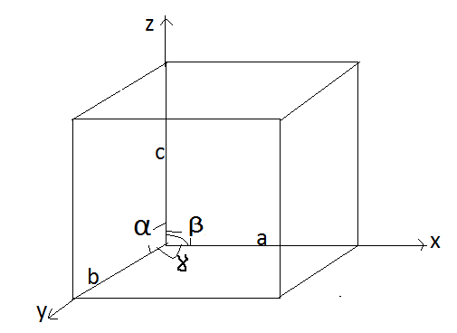
As lattice constants have the dimension of length, their SI unit is the meter. Lattice constants are typically on the order of several angstroms. Lattice constants can be determined using appropriate techniques such as X-ray diffraction.
The volume of the unit cell can be calculated from the lattice constant lengths and angles. If the unit cell sides are represented as vectors, then the volume is the dot product of one vector with the cross product of the other two vectors.
By definition, the lattice vector ‘a’ defines the direction of the X-axis, vector ‘b’ defines the Y-axis and vector ‘c’ the Z-axis. The angle between ‘a’ and ‘b’ vectors is ϒ, between ‘b’ and ‘c’ is α and between ‘a’ and ‘c’ is β.

Wigner-Seitz Cell:
A Wigner-Seitz cell is an example of primitive cell, which is a unit cell containing exactly one lattice point.
The cell may be chosen by first picking a lattice point. After a point is chosen, lines are drawn to all nearby (closest) lattice points. At the mid-point of each line, another line is drawn normal to each of the first set of lines.
In the case of three-dimensional lattice, a perpendicular plane is drawn at the mid-point of the lines between the lattice points. By using this method, the smallest area (or volume in the case of three-dimensional lattice) is enclosed in this way and is called the Wigner-Seitz cell. All area (or space) within the lattice will be filled by this type of primitive cell and will leave no gaps.
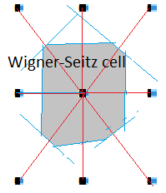
( The Wigner-Seitz cell in the reciprocal space is called the Brillouin zone, which contains the information about whether a material will be conductor, semiconductor or insulator).

